REPORT
Executive summary

The International Symposium on Exploring Visual Cultures took place at the Devonvale Golf and Wine Estate, Cape Town, Western Cape Province South Africa, from 1st to 6th September, 2019. Delegates from seven countries including South Africa, Germany, Uganda, Kenya, Ghana, Cameroon, and Oman) gathered in the Mother City, Cape Town, to discuss the interrelationships between art, culture and society, and illustrate how interpretive diversities can be used in education.

Objectives
The purpose of the symposium was to discuss the use of imageries (objects, images, artefacts, photos and other images) to explore visual cultures from different perspectives.
The specific objectives were:
- To further discuss the criteria for selecting objects, images
- To build capacity on methods of image interpretations ( e.g. meta-analysis)
- To develop capacity of research and material development for education
- To share intercultural experiences
- To write content for the website, books and articles
- To explore partnerships in Cape Town as per MOU between Bavaria and Western Cape
- To develop an exhibition concept and strategy for 2020

Themes
In over 50 sessions run over six days, the symposium covered several themes including the following:
Structure
- Overview of the project
- Website content and structure
- Publications, Books, Journals
- Virtual Museum
International collaboration – decolonialization
- International collaboration between Germany and Africa
- German/African stories
- Reflections on African-European interconnectedness in galleries
- Decolonizing knowledge, power and self as the background context of the project
- Decolonizing art history
- Race
- Decolonial methods
- Intercultural diversity
- Sustainability and Sustainable Development Goals (UN’s SDGs)
Collective memories
- Disruptions in German canon formation
- National memories through artwork
- Photographs as documents
- Politics of art
- Role of Museums and exhibitions
- Surviving political adversaries
Education
- Building criticality at school
- Social learning
- Methodologies
- Reflexivity
Excursions
- Exploring cultures through walk and talk sessions

Outputs
- Relationships and partnershop between seven countries initiated
- Shared experiences, lessons & strategies reflected in regards to the content development
- Book Chapters, papers, articles conceptualized
- Website:
- Criteria for selection of content developed and decided (Figure 1)
- Criteria for analysis and educational material developed and decided (Figure 1)
- Website content developed

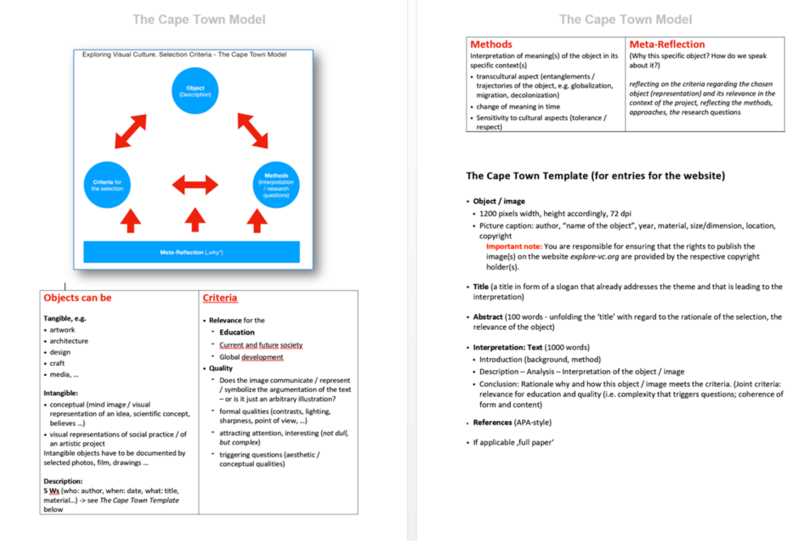
Figure 1

Introduction and Background

Exploring visual cultures is a joint project between the Institute for African Renaissance Studies (IARS), University of South Africa (UNISA) and the Academy of Fine Arts, Munich, Germany. Established in September 2018 with the visit of the German team lead by Dr Prof Ernst Wagner, the project was initiated jointly with Prof Esther Kibuka-Sebitosi at IARS who is the project leader from South Africa.

Project idea
The project focuses on the conscious selection of images / imageries (i.e. artworks, architecture, and design, photos, films, handicraft, and fashion etcetera) in different regions of the world, their respective interpretations, and their use in education. It is international, interdisciplinary, collaborative and multi-perspectival, and it aims at mutual exchange about imageries and their meanings. The leading ideas are:
- To start from the observation that in a globalized world we can find shared, common world-views (expressed in images and imageries) on the one hand and different, distinct, non-shared understandings on the other.
- How we conceive the world, is based on specific repertoires of imagined ideas or imageries that are anchored in the respective collective as well as individual pictorial memory.
- In the context of UNESCO’s Global Citizenship Education (GCE) and Education for Sustainable Development (ESD), peaceful transnational exchange about these imageries is essential.
- The educational systems have a special responsibility in this context, as they offer a space for awareness and reflection on these world-views, and their transformation in collaborative processes.
The project focuses on international cooperation in art and history education - in collaboration with other subjects (such science) where applicable. The project addresses three key areas of interest:
First, how does the selection of “images” (works of art, architecture, design, photos, films, handicraft, fashion etcetera) that are relevant in education take place in different countries? Which ideas shape this selection? How is the own understanding expressed and conceived by the selection? How are the selected objects / images interpreted? Which stories can we tell, which messages do they transport, which narratives convey? Which images are relevant in different educational systems (in the participating countries)? How do they shape the world views of the students? How is the selection justified in the discourse of experts and stakeholders?
Secondly, how can we enter a dialogue about these pictorial repertoires, both linguistically and artistically? How can selection and interpretation be addressed in international cooperation? How can they be used to give deeper insights through cultural comparison? How can they be useful for future pedagogical practice? Can the multi-perspective comprehension lead to a deeper understanding, e.g. of similarities and differences on a global level, because images (as a non-linguistic medium) make different world-views clearer, better understandable, more arguable and assessable?
Thirdly, how can we train stakeholders, educators, teachers to be able to teach visual literacy in this sense? How can images be not only interpreted but also transformed, changed, re-interpreted and/or re-designed in educational contexts?
All the above objectives have the backdrop of the Sustainable Development Goals (SDGS), education and research within the context of decolonization and intercultural interdependencies.

PROJECT PROGRESS
Phase 1: Establishing partnership (started in September 2018)
Partnerships are being developed between the UNISA and the Academy of Fine Arts, Munich. Other key stakeholders from the University of Pretoria, TUT Nairobi, Makerere University, Kenyatta University, UEW Winneba and from Germany, Oman, and other countries are being established. The plan is to sign a MOU between UNISA and the Academy of Fine Arts in 2020. English is the working language for the international cooperation.

Phase 2: Developing content (started in January 2019)
The parallel collection of objects / images in the first step – has started. Selection and interpretation are carried out from the perspective of the respective country’s educational interests and cultural backgrounds. The objects / images are relevant for education in the country of origin. Texts (giving the reasons for the selection, interpretations, hints on how they can be used at schools, in museum education or in teacher training) are written in English, and in the respective national or regional language if required.

Phase 3: Collaborating and exchanging experiences (started in January 2019)
The partners involved will continue to supply content for the website. Using the internet, a database of images is created where they compare their selections, exchange the interpretations and try to find common or diferent views that represent a multi-perspective approach. The interpretations are linguistically, but can be artistically as well.

Phase 4: Publishing (started in March 2019)
In this way, a multi-layered, stimulating pool of materials is created for teacher training and further education, which can also be used for school lessons. The website works as an interactive platform for international exchange and mutual learning. Finally the joint efforts will establish a global database / depot / “virtual museum”. Because it is editable, the database also allows "counter canons" or canon-critical approaches.

Phase 5: Use of the portal (started in September 2019)
On the basis of the website, there can and should be further international cooperation, firstly by involving other countries or by the already existing partners at different levels: Universities and schools can use the materials for their own purpose.

BENEFITS
Teacher training in a global context
The project intends that all teachers and researchers involved acquire intercultural and transcultural competences in a global context. Sustainable development and global citizenship need a cultural foundation. Teacher education in the field of 'cultural education' can make a convincing contribution to this.

International cooperation
Cooperative cooperation in an area that makes different worldviews comprehensible and thus provides cooperation in other areas on an inter-culturally differentiated basis.
Establishment of a web-based platform, which will be further developed even after start-up financing and will be based on e.g. joint seminars of higher education institutions but school exchange is possible in the longer term (sustainable).

Symposium ‘Exploring Visual Cultures’ (Summer School)
1- 6 Sept, 2019 Cape Town, South Africa

Activities leading to the symposium
The German team visited South Africa in September 2018 to introduce the project, plan and develop an action plan. The South African Team followed suite in January, when they visited the Academy of Fine Arts in Munich. During this meeting, a background context was provided and a successful workshop conducted together with students from the Academy. It was agreed to hold a summer school in South Africa to further develop content, build partnerships and engage with scholars from the rest of Africa namely, Ghana, Kenya and Uganda. This summer school should discuss the images posted on the website, new proposals and the key theoretical underpinnings involved.
With the financial support by the Bayerische Staatskanzlei the symposium could be planned by the project coordinators, Prof Esther Kibuka-Sebitosi, Institute for African Renaissance studies, University of South Africa and Prof Dr Ernst Wagner, Academy of Fine Arts, Munich, Germany. Due to the funding of the Bayerische Staatskanzlei partners form Ghana, Cameroon, Uganda, Kenya, and the Oman could be invited as well. This led to a broader and richer view on the work and will help to disseminate the results in more than two contexts.

Delegates
The symposium was graced with 27 participants from seven countries (South Africa, Germany, Oman, Uganda, Kenya and Ghana). They came from a variety of institutions including Universities, Schools, Museums, NGOs, and Government. The experiences ranged from natural sciences to art history, media, professors, curators, business and schoolteachers, among others.
The teams shared experiences in and outside the lecture rooms. They discussed the idea to organize an exhibition as the seven countries plan to host a joint Exhibition in 2021. This will help them further explore the visual cultures and give opportunities to artists in each country to display their work.
Due to the educational nature of the project, the development of university partnerships is key. This will be explored by working together with stakeholders on the ground. To this end, Stellenbosch University was identified as a key stakeholder. Two Professors took part in the symposium (see programme and register attached). Similarly, the delegates visited the Zeitz Museum and held discussions on potential collaboration with the CEO and officials from the Education Section at Zeitz Museum. In Gauteng, the University of Pretoria as well as the TUT were brought on board as partners and were represented by experienced Professors (see programme & register attached).

Symposium Programme and Content / Summaries of the Presentations
Arrival: Sunday 01 September 2019
The delegates arrived on Sunday afternoon and a welcome dinner was held in the evening.

Day 1: Monday 02 Sept 2019
Prof Esther Kibuka-Sebitosi welcomed the delegates and facilitated the introductions. Ms. Johanna Aigner Head of International Office, the Academy of Fine Arts, Munich, delivered the official welcome address. Ms. Aigner stressed the importance of international and cultural exchanges and provided opportunities for this exchange. An artist and art teacher by profession, the head of the International Office has worked at the academy for 13 years in three main areas: maintaining cooperation with international partner universities and being the contact point for all matters relating to international exchange for students, teachers and university staff and shaping the internationalization strategy of the Munich Academy as well as the training of the Academy's teachers in internationalization. She emphasized the manner in which scholarships and exchange of students is done and encouraged us to apply. Ms. Aigner highlighted the importance of international and cultural exchange and networking as well as how the content of this project is implemented and what this means for the training of art teachers. She is transforming the former so-called “Erasmus-Office” with its focus on Europe into an International Office with the aim of widening exchange opportunities with partners outside Europe. With 25% of students coming from outside of Germany, precisely from 43 different countries (10% from other European countries, 10% from Asia, especially South Korea and China, and 5% from the Middle East, United States and Latin America) her goal is to build and deepen connections with African institutions and welcome some of the participants of this symposium in Munich.
Prof Kibuka-Sebitosi gave a brief overview of the project. Prof Ernst Wagner, project leader from the Academy of Fine Arts, provided the background and leading questions. This was followed by the presentation of the website by Dr Annette Schemmel. The context of the African continent and South Africa was given by Prof Kibuka in the presentation entitled “Decolonizing knowledge, power and self”. She ended by introducing the SDGs and importance of green spaces as images of education.
In his paper, “Disruptions in Germany Canon Formation” Prof Ernst Wagner provided an over view of the latent canon and the perceived agreement of what people teach and what is in the school textbooks. He poised critical questions such as: What is in our heritage? What are the most relevant objects in education? Which narratives? Which objects? Which text books? What is our heritage? Is the Eurocentric selection and narratives of linear development still adequate? In essence, “Eurocentric approaches is no longer valid in a globalized world”. He concluded with a variety of models of art development and their significance in teaching.
Prof Bernadette Van Haute of the University of South Africa delivered a presentation on the recent work by Lawrence Lemaoana on Silence Falls. Using the Kanga fabric the artist demonstrated the silence, trade imbalances and culture. Prof Van Haute analyzed several key concepts like ‘Rhodes must fall’ - movement used to portray the plight of South African Youth. Born free, “we are free now what”? they ask. She illustrated the post-apartheid issues in South Africa giving the alternative formulations of a South Africa identity, as portrayed by the artist. The use of Mass Media and the people to shape the powers in the liberty of the poor and issues of state capture for example. Informing us on the diversity of African art, she concluded her paper by showing us the Economic and social divisions, transformation and the dilemma of visual arts in a crisis as they seek out the real. She explaned the idea of global modernity and “Legitimizing Africa as a means of knowledge creation”.
In her presentation, Prof Lize Kriel (Visual Culture Studies, University of Pretoria) used a Christian baptismal bowl inscribed with a biblical text (Matthew 19:14) in the Sepedi language as portal for an exploration into one of the many ‘long conversations’ (Comaroff & Comaroff 1997) between European missionaries and African Christians in Southern Africa. Her methodology is a historical investigation into the object as multiple signifier, covering the period from the last half of the nineteenth century until the twenty-first century. The pewter bowl, an object of German industrial design, probably dates from the 1870s, and was used on Wallmannstahl, a station of the Berlin Mission Society just north of Pretoria. The Wallmansthal congregation comprised of African converts gathered from the Kekana-Ndebele and several other pre-colonial northern Sotho polities.
In the paper entitled, “Reflections on African-European Interconnectedness in the galleries of the Museum Fünf Kontinente in München (Munich)” Karin Guggeis and Stefan Eisenhofer, Museum Fünf Kontinente München, firstly described the origin of the Museum Fünf Kontinente München, the former State Museum of Ethnology Munich, founded as early as 1862 as the first museum of its kind in Germany. It has as very strong tradition since the first decades of the 20th century to present the collected works in its exhibitions as art objects also, not merely as ethnographic specimens to demonstrate the aesthetic and visual qualities of the works and to enhance respect for the persons and cultures who did create these objects. One of the most prominent goals of the current permanent exhibition in the museum on Africa is to demonstrate that Africa is not an isolated continent as presented in many Eurocentric shows, but that this continent is connected with Europe and the world in many ways since centuries and ages. Their lecture clarified that fact that many objects from Africa are examples for the interconnectedness of Africa with the world, but that this is not reflected enough. It was also showed that Africa and Europe do have a common visual heritage since centuries also, but that this is unknown to a broader public until now. Presenting photographs of objects out of the collection of the Museum Fünf Kontinente we will demonstrate that many objects from Africa are rooted in Africa, but that they are inspired in often very specific and unique ways by the world.
Prof George Kyeyune discussed surviving the political adversaries through art by using a sculpture by Nnaggenda. The piece from Makerere University was created between 1984-1990 portrays the political turbulence and economic mismanagement under Idi Amin. Artists did not have much to use and looked for local solutions. Rooted within the context, the image embodies greed, political turbulence and people who don’t want to leave power. The problems in Uganda started way back in the 1962 with independence, the fall of the Buganda Kingdom in 1966 war that left the King in Exile and brought Obote to power. The Amin rule in 1971 and the suffering is all embodied in this image.
In a passionate mood, Avi Sooful delivered an emotional and emphatic presentation about South Africa struggle T-shirts as sites of resistance I which she described the gender-related struggles and contradiction of images won on bodies.
Prof Runette Kruger, TUT spoke about, Remember Marikana stencil, which combines these words with an image of Mgcineni Noki, also known as The man in the green blanket, an iconic symbol of the struggle for dignity and an adequate wage among the poorest workers in South Africa, on whose labour an economy they cannot access, has been built.

Day 2: Tuesday 03 September 2019
Following an overview of Monday by the facilitator, Prof Esther Kibuka, Prof Lize Van Robbroeck from the University of Stellenbosch gave a paper entitled, Blinding Whiteness: what we can learn about settle subjectivity from one painting. This was followed by Bongani Mkhonza, Curator at UNISA who presented the, “Narratives of colonial encounters and violence as part of social imagery”, in the work of Johannes Phokela, “Collateral Damage” (2015). Bongani Mkhonza critically shed light on the history and the deep meanings that are concealed in narratives of colonial encounters and violence. Phokela’s painting appropriates Baroque Art to reference the story of Xhosa Cattle-Killing, Nongqawuse (1841 – 1898). The research is informed by a proposition that, there is something profoundly deviant when, for instance, narratives devised to meet the needs of colonialism continue well into the ‘post-colonial’ era.
Niklas Wolf from the University of Munich (LMU) Germany gave a talk on Walker Evans Photographs and discussed whether they can be approached as documents. It is of interest how African art was seen in the 1920ies through the lens of a western modernist.
The Team from Ghana comprising of Prof Patrique de Graft Yankson, Getrude Nkrumah and Osuanyi Quaicoo Essel, University of Winneba presented on the “Funtumfunefu-deNkemfunefu Stool”. They explained why the stool was selected and how it is interpreted.
Leonard Katete from Nairobi, presented contemporary impressionism depicting his own paintings. Meanwhile Mary Clare Akinyi Kidenda from Kenya gave a paper on the Jua Kali Sector: The foundation of iconic objects and artefacts in Kenya in particular high lighting the Luo Stool. Onyango Oketch, Kenya, presented “The politics of art into life: Censorship and Iconoclasms”. On the other hand Prof Stella Viljoen from Stellenbosch University presented a paper on queer distinctions regarding to the work “A brief analysis of a garden party”.
Fruitful discussions were held on books and journals and how the presentations could be published through these media. Evenings were a good time to network through walk and talk sessions around the beautiful venue.

Day 3: Wednesday 04 September 2019
This was the field day where experiential learning took place. Starting at the culture-center at Spiers Wine Farm Estate, the delegates were treated to music through stone sculptures at the entrance. This was followed by a farm tour expressing fine art and exquisite furniture of the centuries depicting the beauty and elegance of the farm. The farm also trains and gives scholarships to emerging artists and gives them the opportunity to display their creations.
After that the delegates were driven to town by an experienced driver and polite tour guide, Ben Van Jaarsveld. With dinner at the water front, the disappointment of not climbing or going up the cable car to the Table Mountain due to heavy winds was soon forgotten. Back home was late at around 11:00 p.m. Nevertheless, the following morning was fresh early start.

Day 4: Thursday 05 September 2019
Following a feedback session about the field trip by Ben and Esther, the delegates listened to Edward Mwaura Ndekere who spoke about the construction of a downdraft kiln using locally available materials in Kenya. This was followed by a ‘decolonial methodologies and sustainability forum’ conducted by Prof Wagner and Prof Kibuka. This session sent into a workshop on planning and decolonial methods. Other topics such as work plans and funding as well as website development were discussed.
The work of Dr Juan Carlos A. Sandoval Rivera depicting sustainable principles through photography was displaced and presented by Prof Esther Kibuka. Apart from the fact that Carlos is not a professional photographer which disadvantaged him among a group of artists, the photos drew much interest and deep thought.
Intense discussions on the website content, selection of images and meta-analysis resulted into the development of guidelines and principles (figure 1) above and content guidelines.

Day 5: Friday 06 September 2019
This was the final day of the symposium and it started on a high note. The website content brought much discussions, singing and dancing as each country group planned and presented their plans.
It was decided that a joint exhibition will be held in 2020 or 2021 at UNISA. Joint partnerships would be established on this endeavor. The publications and website development were all going on thereby yielding the outputs below.
Outputs
- Website content developed
- Book Chapters conceptualized
- Paper/articles developed
- Partners developed
- Experiences, lessons shared & strategies developed
- Criteria for website developed
Feedback and Evaluation
Through questionnaires the feedback from delegates was gathered. Most of the participants (99%) found the symposium content appropriate and applicable to their jobs. Similarly they found the programme well spaced, venue excellent and material well organized. They liked the leadership styles of the facilitators.
Regarding the most appreciated topic or enjoyed the most the following were some of the responses:
- “The possibility to learn from and meet so many people from different countries and about art education in their countries. GREAT EXPERIENCE”
- “Academic exchange, been given more possibilities on research topics, internationally”
- “Being individuals from 7 countries were become a very harmonic and effective team due to our excellent leaders, Prof Esther & Prof Ernst”
- “Transformation city, organization/availability of the organizers”
When asked which topics or aspects of the symposium they found most useful, the delegates replied,
- “The relaxing and interactive way at the workshop and the different ways of learning from many perspectives with a global dimension”
- “When we talked about the revelation of art by different cultures in terms of what is right or effective”
- “The process of agreeing on joint notions of complex terminology that is different interpreted in different participating delegations”
- “Unity of purpose and diversity of views towards the exploration of visual cultures through blurring of nationalistic boundaries for training global citizens”
Which topics/activities they would like to be involved in next 12 months:
- “Decoloniality”
- “Afrocentricity”
- “Art development”
- “Curriculum”
The Symposium was closed by Prof Esther Kibuka and Prof Ernst Wagner at 13:00 P.m. after the evaluation session.

Reflection
Context
Visual cultures are important because they tell stories of the past, present and future of a generation. Culture and identity are intricately linked. For centuries, people have used images, objects, artefacts to describe what is going on in society and to give expressions of their fears, hopes and resolutions. South Africa, like Germany has a troubled past. Racism, slavery, apartheid and human suffering are all too familiar. The role of visual arts in exploring the complex histories has often been expressed in books, films, plays, paintings but not commonly virtually. With the fourth industrial revolution backed by technology, the project on Exploring Visual Cultures was conceptualized as an online platform to develop knowledge from multi-disciplines and multiple interpretations. Utilizing meta-analysis, the different images, objects, photographs and artefacts are analyzed from the South Africa and German perspective.

Significance of the project
Above all, the different interpretations of an image or object often tells us the people’s culture, identity and being. The need to find social cohesion, transform societies and understand their history is not an easy journey. Throughout the use of art, visual images and artefacts, people have the opportunity to interpret, think through and give meaning to the object, image or piece of art. On the one hand, South Africa is trying to deal with racism, inequality, poverty, colonialism, segregation and the dual economy. German, on the other hand is dealing with the reunification, past troubles of an ageing population, antisemitism and sustainability, to mention but a few. Many common themes in society have been, and continue to be expressed in visual images, arts, artefacts and other mediums.
For this reason, Exploring Visual Cultures provides a platform online and through face-to-face discussions where different interpretations are given by both teams. The teaching materials and education systems have largely ignored the various perspectives given people from different cultures yet the two countries deal with diversity on a daily basis. The project provides avenues in which unity in diversity are expressed. In addition, the project provides opportunities for staff and students to exchange information, knowledge and images online. Decolonial thinking as well as active learning underpin this blended learning. In a way it is an all-encompassing social learning because people from different cultures share experiences and knowledge. Capacity building for staff, researchers and postgraduate students as well as teachers for schools is vital for the project.

Over all objectives of the symposium
Against this background, the symposium in Cape Town focused on the further development of the website, developing criteria for the images, social interaction, creating new knowledge and methodologies for interpretations of images. The question of how and why certain images are selected was discussed among other key questions and principles and guidelines established (Figure 1). In addition, joint publications were discussed and topics identified for Book Chapters, Journal articles and magazines. This will be online and print forms. The possibilities of using the International Journal of African Renaissance studies and other international Journals was agreed upon.

Objectives of the symposium were as follows:
- To further discuss the criteria for selecting objects, images
- To build capacity on Methods of image interpretations (e.g meta analysis)
- To develop capacity of research and material development for education
- To share intercultural experiences
- To write content for the website, books and articles
- To explore partnerships in Cape Town as per MOU between Bavaria and Western Cape
- To develop exhibition concept and strategy for 2020

Results and follow-ups
Since the State of Bavaria and the Western Cape Government have an MOU (see figure 2, signed in 2016) that the project would like to link with, further investigation is needed in respect to this.
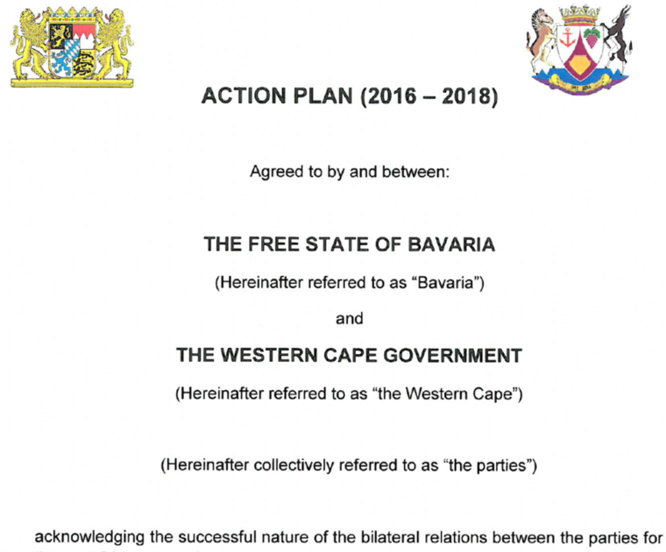
Figure 2 – Screenshot MoU

Report compiled by Project Coordinators:
Prof Esther Kibuka-Sebitosi, Institute for African Renaissance studies, University of South Africa and Prof Dr Ernst Wagner, Academy of Fine Arts, Munich, Germany.

Annex 1 contains the symposium programme and Annex 2 the attendance registers. The detailed presentations are provided in the internal section of the website.

Annex 1
PROGRAMME

Sunday 01 September 2019
Arrival | Arrival of Participants, Airport Pick up and shuttle to Devonvale Golf & Wine Estate
19:30 | Welcome Dinner

Monday 02 September 2019
08:30-8:45 | Welcome and Introduction of participants | Prof Esther Kibuka-Sebitosi, Project Coordinator, UNISA, South Africa
08:45-9:00 | Welcome address | Johanna Aigner  Head of International Office, Academy of Fine Arts Munich
09:00-9:15 | Overview of project | Prof Esther Kibuka
09:15-9:30 | Background and leading questions | Prof Ernst Wagner  Academy of Fine Arts, Munich Germany
09:30-9:45 | Presentation of the website how it exists so far | Dr Annette Schemmel & Prof Ernst Wagner
09:45-10:00 | Decolonizing Knowledge, Power and Self- background  Green spaces | Prof Esther Kibuka
10:00-10:15 | Disruptions in German Canon Formation | Prof Ernst Wagner
10:15-10:30 | Decolonize art history | Prof Bernadette Van Haute, UNISA
10:30-10:50 | Discussion
10:50 | TEA BREAK AND GROUP PHOTO
11:10-11:40 | An inscribed bowl found in the veld and its German/African stories | Prof Lize Kriel  University of Pretoria
11:50-12:20 | National memory trough arts work in Cameroon. | Prof Paul-Henri Souvenir Assako Assako, Gabrielle Djiwat (University of Yaoundé I, Cameroon)
12:20-12:35 | Reflections on African-European Interconnectedness in the galleries of the Museum Fünf Kontinente in Munich | Karin Guggeis & Dr. Stefan Eisenhofer, Museum Fünf Kontinente, Munich
12:35-12:50 | Surviving political adversities through recovery of past traditions: an account of WAR VICTIM, a sculpture by Francis Nnaggenda | Prof George Kyeyune  Makerere University, College of Engineering Design Art and Technology
13:00 | LUNCH
14:00-14:30 | Group Discussions: Criteria for selecting images
14:30-14:45 | Feedback from Groups | Prof Esther Kibuka
14:45-15:00 | South African struggle t-shirts as sites of resistance | Avi Sooful, University of Pretoria
15:00-15:15 | Building Criticality at School: An Artistic Revision of Man Ray's Photo "Noir et Blanche" | Annette Schemmel, Germany
15:15-15:30 | Remembering Marikana | Prof Runette Kruger,  TUT
15:30-15:45 | Group Discussions: Questions to the Project / Options for Publications | Prof Esther Kibuka
15:45-16:15 | Feedback over Tea | Prof Esther Kibuka
16:15- Dinner | Informal Discussions, Networking, Walk and Talk

Tuesday 03 September 2019
09:00-9:05 | Overview of yesterday | Prof Esther Kibuka & Prof Ernst Wagner
09:05-9:20 | Blinding Whiteness: what we can learn about settler subjectivity from one painting. | Prof Lize van Robbroeck, University of Stellenbosch, South Africa
09:20-9:35 | Walker Evans. Photographs as documents? African art through the lens of a modernist | Niklas Wolf, University of Munich (LMU), Germany
9:35-9:45 | Presidential Posters | Bongani Mkhonza, UNISA
9:45-9:55 | Experiences from Ghana | Prof Patrique deGraft-Yankson, University of Education Winneba, Ghana
09:55-10:10 | The ‘FUNTUMFUNEFU-DԑNKYԑMFUNEFU’ STOOL: Why the stool has been chosen and how it is interpreted | Prof Patrique deGraft-Yankson  Gertrude Nkrumah  Osuanyi Quaicoo Essel (University of Education Winneba, Ghana)
10:10-10:30 | TEA
10:30-10:45 | Contemporary Impressionism | Leonard Kateete
11:15-11:30 | Visual image from Oman | Prof Fakhriya Khalfan Nasser Al-Yahyai, Prof Mohammed Hamood Khalfan Al-Amri, Oman
11:45-12:00 | Group Discussions: Content development | Prof Esther Kibuka
12:00-12:15 | Feedback | Prof Esther Kibuka
12:15-12:30 | Jua Kali Sector: The foundation of iconic objects and artefacts in Kenya | Mary Clare Akinyi Kidenda, Kenya
12:30-12:45 | The Politics of Art into Life: Censorship and Iconoclasm | Prof Onyango Oketch, Kenya
12:45-14:00 | Lunch
14:00-14:15 | Queer Distinction? A Brief Analysis of a Garden Party | Prof Stella Viljoen  Stellenbosch University
14:30-15:00 | Work in Country Groups: Develop Work plans | Esther
15:00-15:30 | Feedback | Facilitator Esther
15:30-15:45 | Discussions over TEA
15:45-16:00 | Introduction Book & Journal Projects | Ernst & Esther
16:00- Dinner | Informal Discussions, Networking, Walk and Talk

Wednesday 04 September 2019
8:30 / 9:00  Departure | Field Visit to Spiers, Art at a Wine Farm  NORVAL Museum | Ben and Esther
12:00-14:00 | Lunch Water front | Ben and Esther
14:00-16:00 | Zeitz Museum | Richard Kilpert  Zeitz Museum Educator
16:00-18:30 | Sunset Table Mountain | Ben and Esther
Dinner | Water front | Ben and Esther
20:00 | Return | Ben and Esther

Thursday 05 September 2019
9:00-9:10 | Feedback from yesterday | Esther and Ben
9:10-9:25 | Construction of a downdraft kiln using locally available materials in Kenya | Edward Mwaura Ndekere
9:25-9:40 | Decolonial Methods, Sustainability | Esther & Ernst
9:40-9:55 | Discussions | Esther
10:00 | TEA
10:20-11:20 | Workshop planning: Methodology, Decolonial Methods, Sustainability, SDGs and Writing Content | Ernst and Esther
11:20-11:50 | Work plans and Funding | Ernst and Esther
11:50-12:20 | Website Development | Ernst
12:00-13:30 | Lunch
13:30-14:00 | Mexico: Intercultural diversity- Skype | Carlos, University of Veracruz
14:00-14:30 | Writing and Publications | Esther & Ernst
14:30-16:00 | Transnational Working Groups
16:00- Dinner | Informal Discussions, Networking, Walk and Talk

Friday 06 September 2019
9:00-05 | Reflections | All
9:05-10:00 | Website Content, Structure and Branding | Ernst
10:00-10:30 | Evaluation | Esther
10:30-11:00 | Country group reflection and way forward – Information to the whole group
11:00-11:30 | Way forward and closure | Ernst
12:00-13:00 | Lunch and Departure | Esther and Ben

Annex 2

Participants

South Africa
- Stella Viljoen | Stellenbosch University
- Richard Kilpert | Zeitz Mocca Museum
- Ben Van Jaarsveld | Cape Town
- Esther Kibuka-Sebitosi | University of South Africa
- Bongani Wisdom Mkhonza | University of South Africa
- Bernadette Maria De Kimpe | University of South Africa
- Lize Kriel | University of Pretoria
- Runette Kruger | Tshwane University of Technology (TUT)
- Avi Sooful | University of Pretoria

Germany
- Ernst Wagner | Academy of Fine Arts Munich
- Johanna Aigner | Academy of Fine Arts Munich
- Annette Schemmel | Institute for School Quality and Educational Research
- Niklas Wolf | University of Munich, Department for Art History
- Stefan Eisenhofer | Museum 5 Kontinente, Munich
- Karin Guggeis | Museum 5 Kontinente, Munich

Ghana
- Patrique deGraft-Yankson | University of Education Winneba
- Gertrude NKRUMAH | University of Education Winneba
- Osuanyi QUAICOO ESSEL | University of Education Winneba

Kenya
- FRANCIS KENNEDY ONYANGO OKETCH | Technical University Nairobi
- Mary Clare Akinyi Kidenda | Technical University Nairobi
- EDWARD MWAURA NDEKERE | Kenyatta University

Oman
- Fakhriya Khalfan Nasser Al-Yahyai | Sultan Qaboos University Oman
- Mohammed Hamood Khalfan Al-Amri | Sultan Qaboos University Oman

Uganda
- Walungama Leonard Kateete | Independent Artist
- George Kyeyune | Makerere University

Cameroon
- Paul-Henri Souvenir Assako Assako | University of Yaoundé I. // Libre Académie des Beaux-Arts Douala
- MYSTERE GABRIELLE DJIWAT | University of Yaoundé I.

